Part 1 .

We can login to the Linux system in the WEB Lab with one of the following IP addresses:

146.245.252.25

146.245.252.26

On a Windows computer:

Download the 64-bit PUTTY.msi to your computer

Double click on the PUTTY icon to launch the program

Click on session on the left and type in one of the IP addresses from above.

Click open and log in with Linux username and Linux password.

Part 2.

**curl** is a command line tool to transfer data to or from a server

# Display Linux system information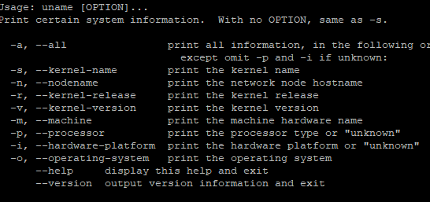

uname -a - Linux sol25 3.10.0-1160.11.1.el7.x86_64 #1 SMP Tue Dec 15 08:51:23 CST 2020 x86_64 x86_64 x86_64 GNU/Linux

Uname -r - 3.10.0-1160.11.1.el7.x86_64

System up time 02:36:16 up 39 days, 17:20, 1 user, load average: 0.00, 0.01, 0.05- can be accessed by typing **uptime .**